Use the same parameters to compare the centroids generated from Weka and R implementations of k-means.

We can see that the total ‘within cluster sum of squared errors’ is much lower on the R computation.

There are some slight differences in the grouping of observations. My assumption is that R more accurately grouped points together.

Weka:

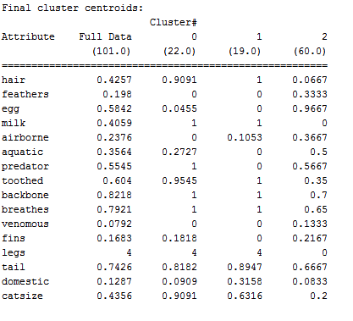kMeans

======

Number of iterations: 3

Within cluster sum of squared errors: 370.36711436711437

R:



Within cluster sum of squares by cluster:

[1] 35.21429 146.88372 85.06818

(between_SS / total_SS = 61.9 %)